VARUN BHARGAVA – 241010282
DATA STRUCTURES TASK-6

Task 01: Postfix to Prefix:
( https://github.com/varunnnb/dsa-sem3-iiitnr/blob/main/lab6/lab6-1.c)
Example: Convert the following Postfix expression into Prefix expression:

AB + CD − ∗

Prefix expression:

∗ + AB − CD

Question:
Convert the following Postfix expression into Prefix using stack operations:

P Q + RS ∗ T U − +V W/∗

SOLUTION:
++PQ*+*RS-TU/VW

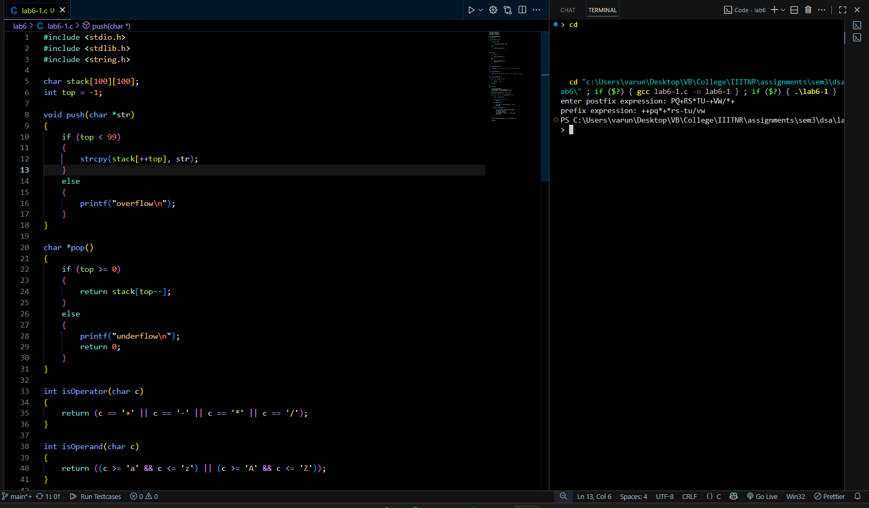
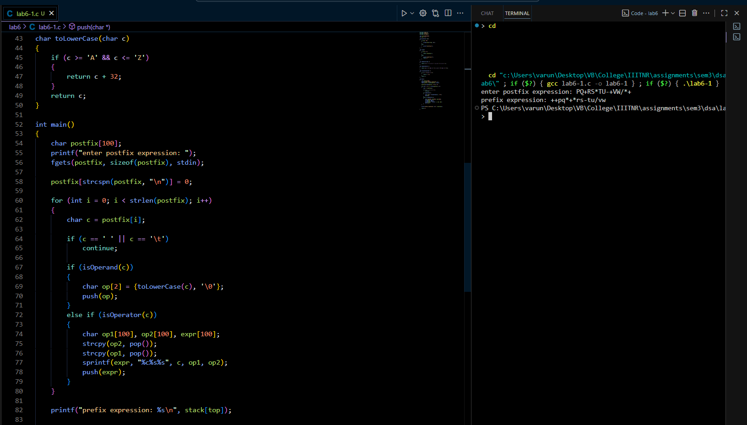

Task 02: Stack-based Parentheses Checker:
( https://github.com/varunnnb/dsa-sem3-iiitnr/blob/main/lab6/lab6-2.c)
Write a program using a stack to check whether a given expression has balanced paren-
theses or not. The expression may include the symbols: (), {}, and [].

• Display “Balanced” if all parentheses are matched properly, otherwise “Not Bal-
anced”.

Examples:
• Input: { [ ( A + B ) * ( C + D ) ] }
Output: Balanced
• Input: { ( A + B ] }
Output: Not Balanced
Expressions to check:
1. { [ ( A + B ) * ( C + D ) ) }
2. ( A + B ] { C + D }
3. { ( [ A + B ] * C ) - D }

SOLUTION:
- NOT BALANCED
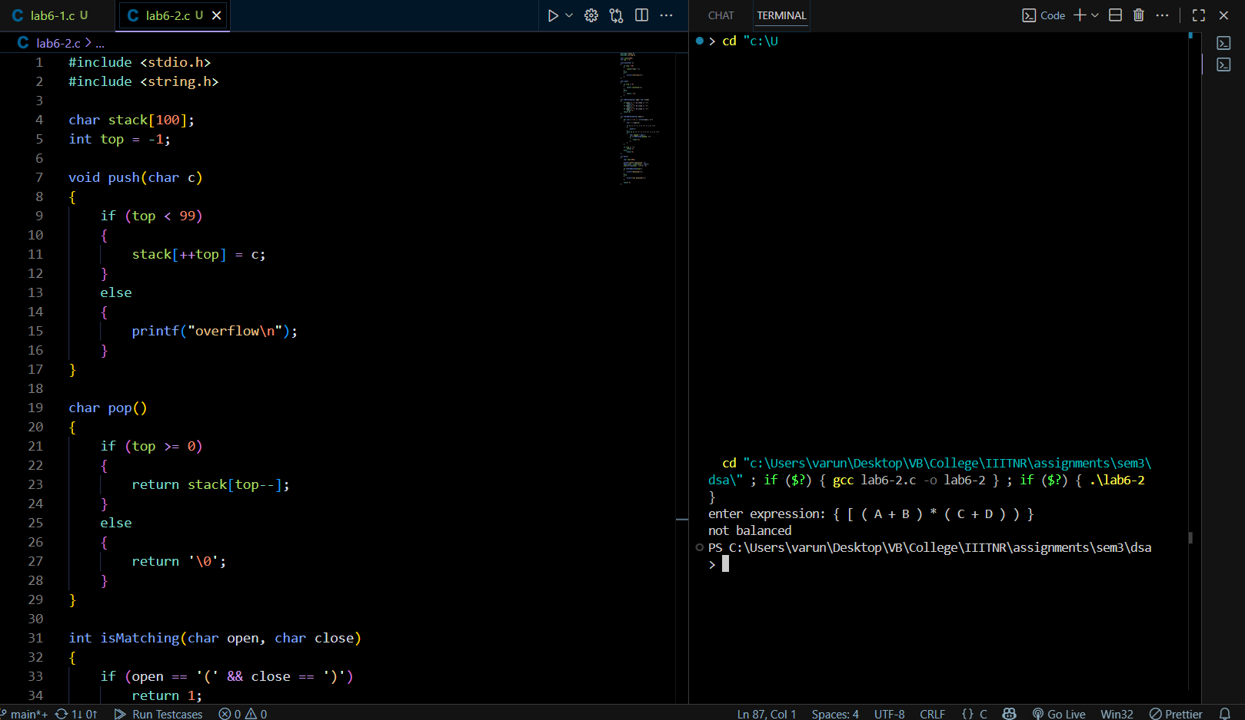
- NOT BALANCED
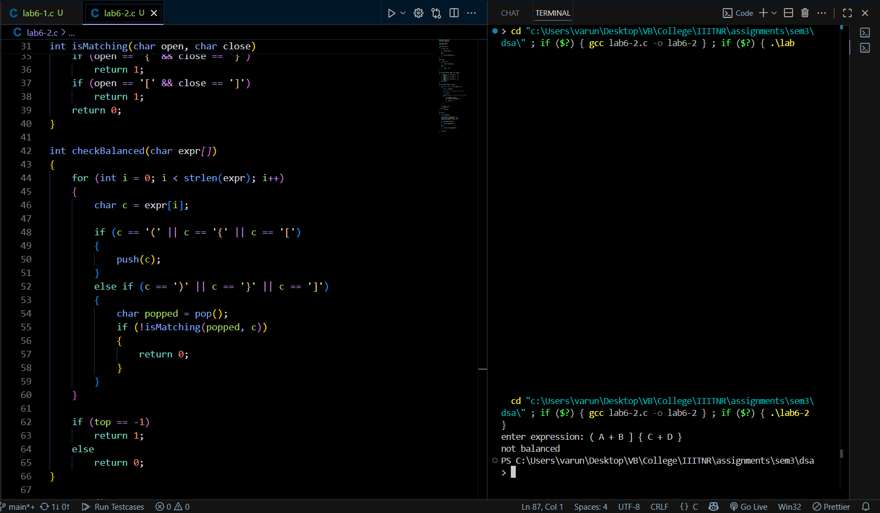
- BALANCED
